**CS4478/CS5413**

**Game Programming**

**Dr. Sabah Mohammed**

**Department of Computer Science**

**Assignment 2: Memory Game in UNITY (10 Marks = 30 Points)**  

You are requested to program a memory game called cartoon character in Unity 2D. You need to create 4 by 4 screen with blank cards. If you flip two unmatched cards these cards will flip again and you will play another round. Once you identified all the characters you should produce a Game over Screen with option to play again where the animals will have different positions. You will find the sprites with this assignment folder.

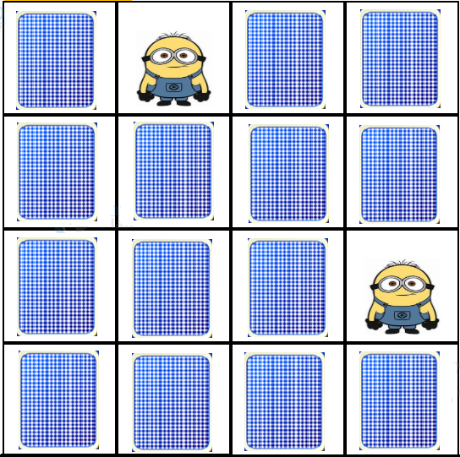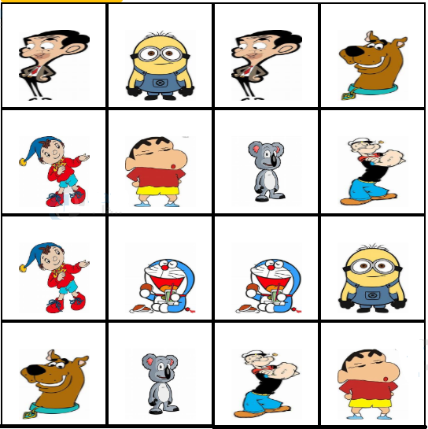

**Grading Criteria**

|  |  |  |  |  |  |
| --- | --- | --- | --- | --- | --- |
| **Base Grade** | | | | | |
| **Categories** | **A** | **B** | **C** | **D** | **F** |
| Programming (Unity 2D) | 9-10 | 8 | 7 | 6 | <=5 |
| Scene and Cards Flipping | 9-10 | 8 | 7 | 6 | <=5 |
| Documentation Efforts (ReadMe) | 9-10 | 8 | 7 | 6 | <=5 |
| **Total** | **0–30** | | | | |
| **Adjustments** | | | | | |
| Game has minor technical flaw(s) | –3 | | | | |
| Game does not work | –15 | | | | |
| Failed to turn-in resources | –3 | | | | |
| Missed deadline | –3/hr | | | | |

|  |  |
| --- | --- |
| **Evaluation Key Criteria** | |
| **A** | Professional quality work. |
| **B** | Above average student work. Goes above and beyond what's required. |
| **C** | Average student work. Meets the minimum requirements of the project. |
| **D** | Below average work. Fails to meet minimum standard. |
| **F** | Incomplete or very poor. |

**Note:** Respecting the student behaviour code is highly appreciated:

https://www.lakeheadu.ca/faculty-and-staff/policies/student-related/code-of-student-behaviour-and-disciplinary-procedures